**Demons – imagine dragons**

|  |  |  |  |  |
| --- | --- | --- | --- | --- |
| Verse 1 | C | G | Am | F |
| C | G | Am | F |

|  |  |  |  |  |
| --- | --- | --- | --- | --- |
| Pre-Chorus | C | G | Am | F |
| C | G | Am | F |

|  |  |  |  |  |
| --- | --- | --- | --- | --- |
| Chorus | C | G | Am | F |
| C | G | Am | F |

|  |  |  |  |  |
| --- | --- | --- | --- | --- |
| Verse 2 | C | G | Am | F |
| C | G | Am | F |

|  |  |  |  |  |
| --- | --- | --- | --- | --- |
| Pre-Chorus | C | G | Am | F |
| C | G | Am | F |

|  |  |  |  |  |
| --- | --- | --- | --- | --- |
| Chorus | C | G | Am | F |
| C | G | Am | F |

|  |  |  |  |  |
| --- | --- | --- | --- | --- |
| Bridge | C | G | Am | F |
| C | G | Am | F |

|  |  |  |  |  |
| --- | --- | --- | --- | --- |
| Chorus | C | G | Am | F |
| C | G | Am | F |

**Demons – imagine dragons**

**Gitarre - Akkorde**

**F**

|  |  |  |  |  |
| --- | --- | --- | --- | --- |
|  |  |  |  |  |
|  |  |  |  |  |
|  |  |  |  |  |
|  |  |  |  |  |
|  |  |  |  |  |

**F**

|  |  |  |  |  |
| --- | --- | --- | --- | --- |
|  |  |  |  |  |
|  |  |  |  |  |
|  |  |  |  |  |
|  |  |  |  |  |
|  |  |  |  |  |

**Am**

|  |  |  |  |  |
| --- | --- | --- | --- | --- |
|  |  |  |  |  |
|  |  |  |  |  |
|  |  |  |  |  |
|  |  |  |  |  |
|  |  |  |  |  |

**G**

|  |  |  |  |  |
| --- | --- | --- | --- | --- |
|  |  |  |  |  |
|  |  |  |  |  |
|  |  |  |  |  |
|  |  |  |  |  |
|  |  |  |  |  |

**C**

|  |  |  |  |  |
| --- | --- | --- | --- | --- |
|  |  |  |  |  |
|  |  |  |  |  |
|  |  |  |  |  |
|  |  |  |  |  |
|  |  |  |  |  |



**Gitarre – Töne**



|  |  |  |  |  |
| --- | --- | --- | --- | --- |
|  |  |  |  |  |
|  |  |  |  |  |
|  |  |  |  |  |
|  |  |  |  |  |
|  |  |  |  |  |



|  |  |  |  |  |
| --- | --- | --- | --- | --- |
|  |  |  |  |  |
|  |  |  |  |  |
|  |  |  |  |  |
|  |  |  |  |  |
|  |  |  |  |  |



|  |  |  |  |  |
| --- | --- | --- | --- | --- |
|  |  |  |  |  |
|  |  |  |  |  |
|  |  |  |  |  |
|  |  |  |  |  |
|  |  |  |  |  |

|  |  |  |  |  |
| --- | --- | --- | --- | --- |
|  |  |  |  |  |
|  |  |  |  |  |
|  |  |  |  |  |
|  |  |  |  |  |
|  |  |  |  |  |



**Demons – imagine dragons**

**Gitarre - Akkorde**

**F**

|  |  |  |  |  |
| --- | --- | --- | --- | --- |
|  |  |  |  |  |
|  |  |  |  |  |
|  |  |  |  |  |
|  |  |  |  |  |
|  |  |  |  |  |

**F**

|  |  |  |  |  |
| --- | --- | --- | --- | --- |
|  |  |  |  |  |
|  |  |  |  |  |
|  |  |  |  |  |
|  |  |  |  |  |
|  |  |  |  |  |

**Am**

|  |  |  |  |  |
| --- | --- | --- | --- | --- |
|  |  |  |  |  |
|  |  |  |  |  |
|  |  |  |  |  |
|  |  |  |  |  |
|  |  |  |  |  |

**G**

|  |  |  |  |  |
| --- | --- | --- | --- | --- |
|  |  |  |  |  |
|  |  |  |  |  |
|  |  |  |  |  |
|  |  |  |  |  |
|  |  |  |  |  |

**C**

|  |  |  |  |  |
| --- | --- | --- | --- | --- |
|  |  |  |  |  |
|  |  |  |  |  |
|  |  |  |  |  |
|  |  |  |  |  |
|  |  |  |  |  |



**Gitarre – Töne**

|  |  |  |  |  |
| --- | --- | --- | --- | --- |
|  |  |  |  |  |
|  |  |  |  |  |
|  |  |  |  |  |
|  |  |  |  |  |
|  |  |  |  |  |



|  |  |  |  |  |
| --- | --- | --- | --- | --- |
|  |  |  |  |  |
|  |  |  |  |  |
|  |  |  |  |  |
|  |  |  |  |  |
|  |  |  |  |  |



**Demons – imagine dragons**

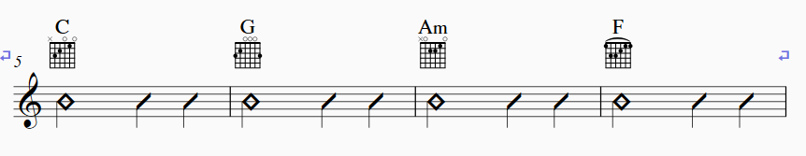



|  |  |  |  |  |
| --- | --- | --- | --- | --- |
| **Pre-Chorus** | C | G | Am | F |
| C | G | Am | F |

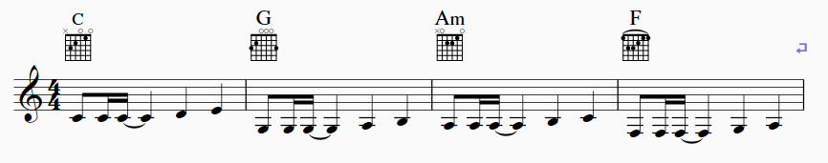**oder:**



|  |  |  |  |  |
| --- | --- | --- | --- | --- |
| **Chorus**  **Achtel** | C | G | Am | F |
| C | G | Am | F |

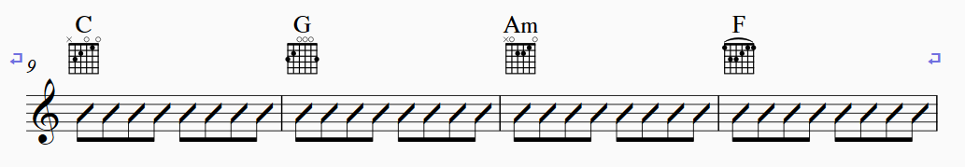



**Demons – imagine dragons**

|  |  |  |  |  |
| --- | --- | --- | --- | --- |
| **Verse**  Auf 1 anschlagen | C | G | Am | F |
| C | G | Am | F |

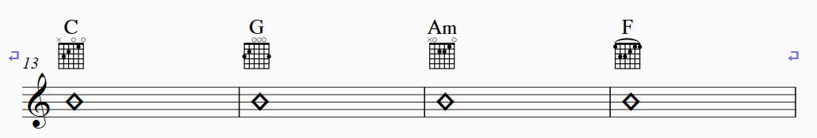



|  |  |  |  |  |
| --- | --- | --- | --- | --- |
| **Bridge** | C | G | Am | F |
| C | G | Am | F |

