**Demons Klavier**



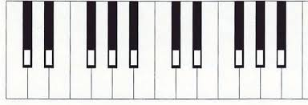

**Ablauf:** Verse 1 (8T) - Pre-Chorus (8T) - Chorus (8T) – Verse 2 (8T) - Pre-Chorus (8T) - Chorus (8T) - Bridge (8T) - Refrain (8T)

**Stimme 1:**

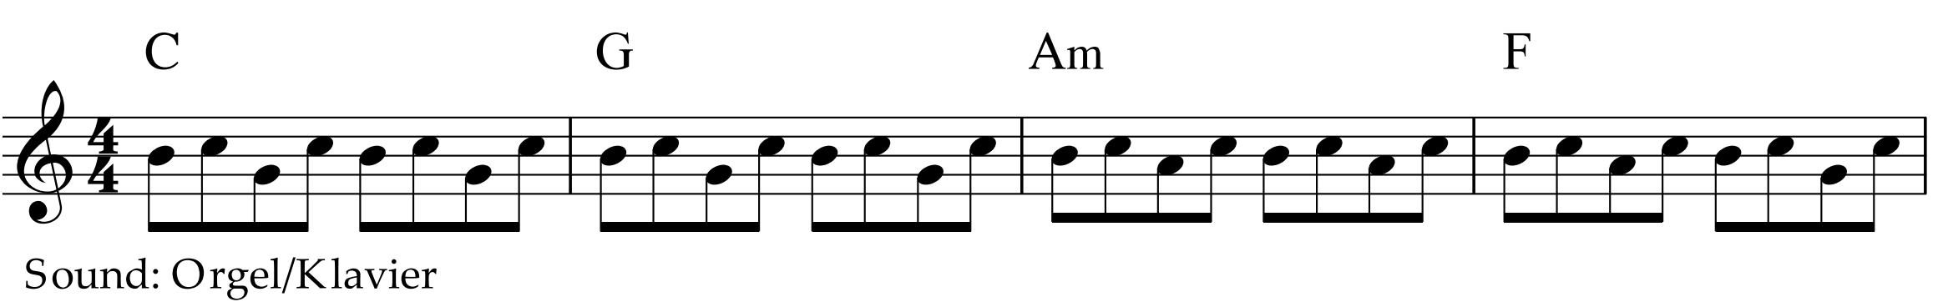

**Stimme 2:**

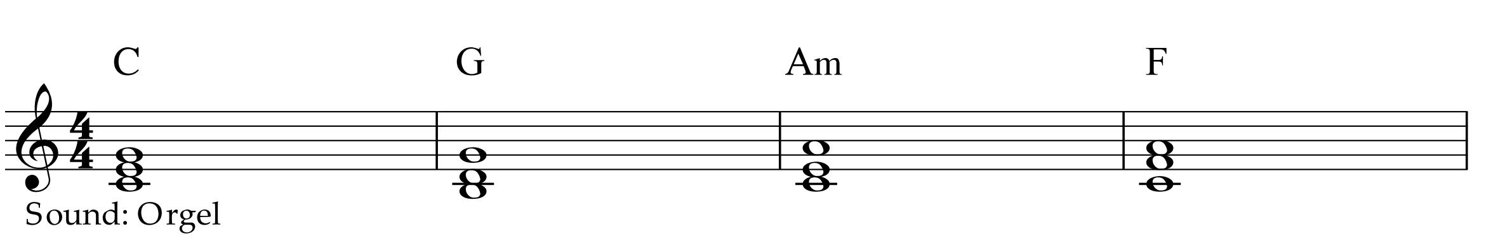

**Demons – imagine dragons**

|  |  |  |  |  |
| --- | --- | --- | --- | --- |
| Verse 1 | C | G | Am | F |
| C | G | Am | F |

|  |  |  |  |  |
| --- | --- | --- | --- | --- |
| Pre-Chorus | C | G | Am | F |
| C | G | Am | F |

|  |  |  |  |  |
| --- | --- | --- | --- | --- |
| Chorus | C | G | Am | F |
| C | G | Am | F |

|  |  |  |  |  |
| --- | --- | --- | --- | --- |
| Verse 2 | C | G | Am | F |
| C | G | Am | F |

|  |  |  |  |  |
| --- | --- | --- | --- | --- |
| Pre-Chorus | C | G | Am | F |
| C | G | Am | F |

|  |  |  |  |  |
| --- | --- | --- | --- | --- |
| Chorus | C | G | Am | F |
| C | G | Am | F |

|  |  |  |  |  |
| --- | --- | --- | --- | --- |
| Bridge | C | G | Am | F |
| C | G | Am | F |

|  |  |  |  |  |
| --- | --- | --- | --- | --- |
| Chorus | C | G | Am | F |
| C | G | Am | F |