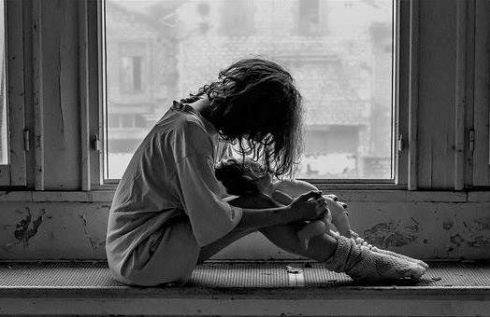

**Notizen:**

|  |
| --- |
|  |
|  |
|  |
|  |
|  |
|  |

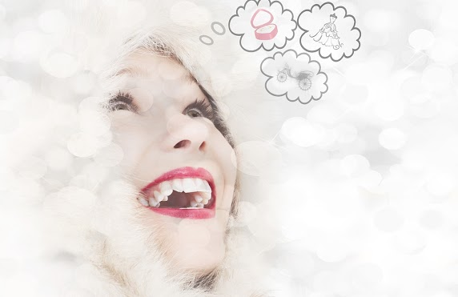

**Notizen:**

|  |
| --- |
|  |
|  |
|  |
|  |
|  |
|  |

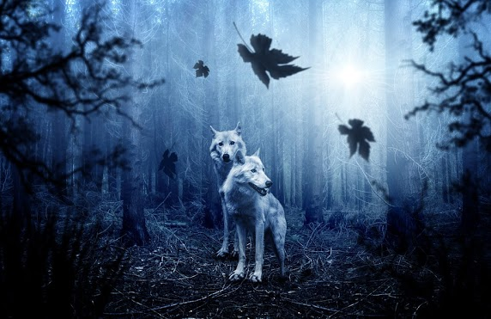

**Notizen:**

|  |
| --- |
|  |
|  |
|  |
|  |
|  |
|  |

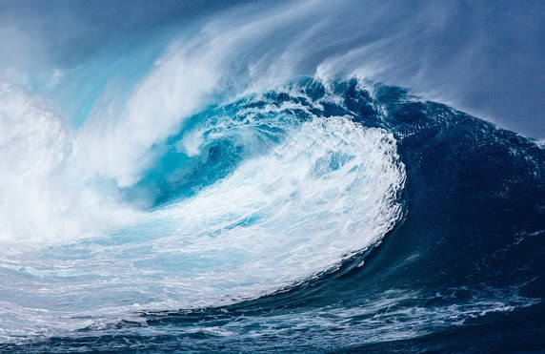

**Notizen:**

|  |
| --- |
|  |
|  |
|  |
|  |
|  |
|  |

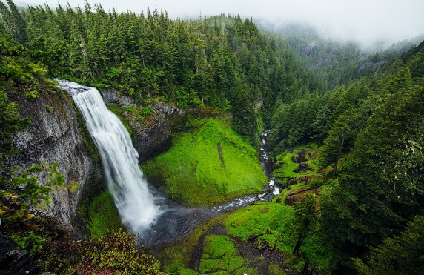

**Notizen:**

|  |
| --- |
|  |
|  |
|  |
|  |
|  |
|  |

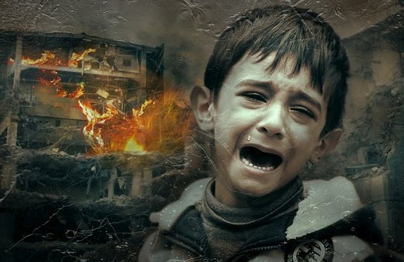

**Notizen:**

|  |
| --- |
|  |
|  |
|  |
|  |
|  |
|  |



**Notizen:**

|  |
| --- |
|  |
|  |
|  |
|  |
|  |
|  |



**Notizen:**

|  |
| --- |
|  |
|  |
|  |
|  |
|  |
|  |

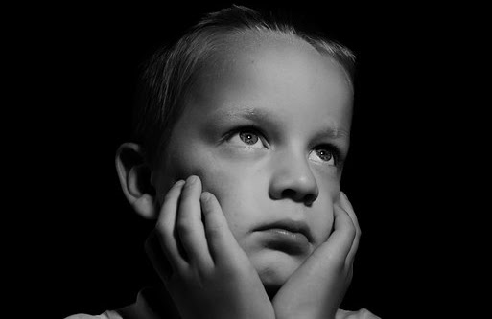

**Notizen:**

|  |
| --- |
|  |
|  |
|  |
|  |
|  |
|  |

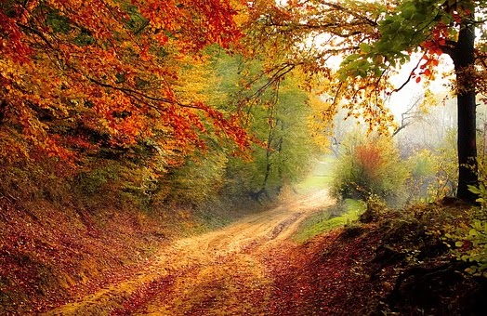

**Notizen:**

|  |
| --- |
| Wald, geheimnisvoll, fröhlich, bunt, träumerisch, |
| aufregend, spannend, Natur, wild, entspannend, |
| C-Dur, laufen, wandern, Vita Parcours, Tag, |
| Tiere, Blätter fallen, Jahreszeiten, Zeit vergeht, |
| Freude, frische Luft |
| **Geräusch: Vogelgezwitscher** |

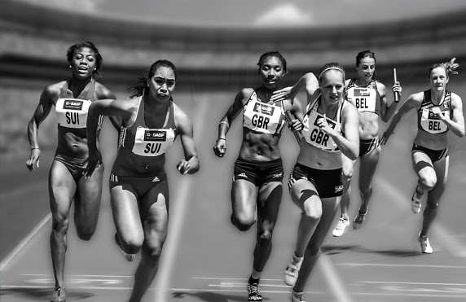

**Notizen:**

|  |
| --- |
|  |
|  |
|  |
|  |
|  |
|  |

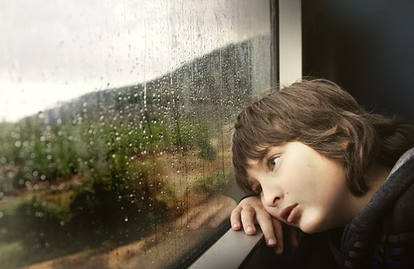

**Notizen:**

|  |
| --- |
|  |
|  |
|  |
|  |
|  |
|  |



**Notizen:**

|  |
| --- |
|  |
|  |
|  |
|  |
|  |
|  |

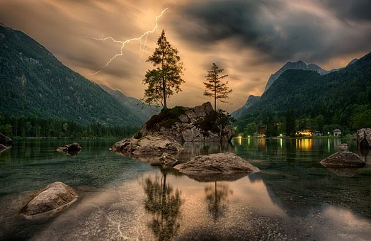

**Notizen:**

|  |
| --- |
|  |
|  |
|  |
|  |
|  |
|  |

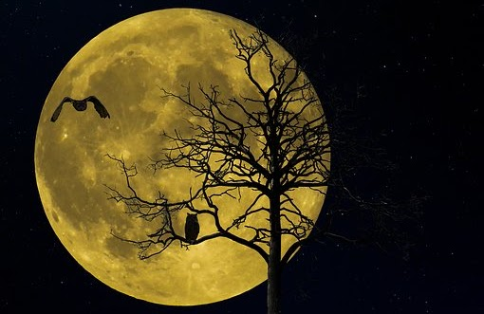

**Notizen:**

|  |
| --- |
|  |
|  |
|  |
|  |
|  |
|  |

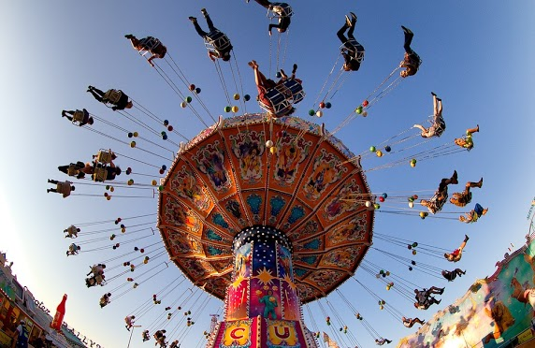

**Notizen:**

|  |
| --- |
|  |
|  |
|  |
|  |
|  |
|  |



**Notizen:**

|  |
| --- |
|  |
|  |
|  |
|  |
|  |
|  |

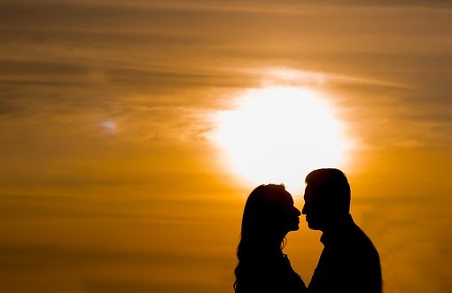

**Notizen:**

|  |
| --- |
|  |
|  |
|  |
|  |
|  |
|  |



**Notizen:**

|  |
| --- |
|  |
|  |
|  |
|  |
|  |
|  |

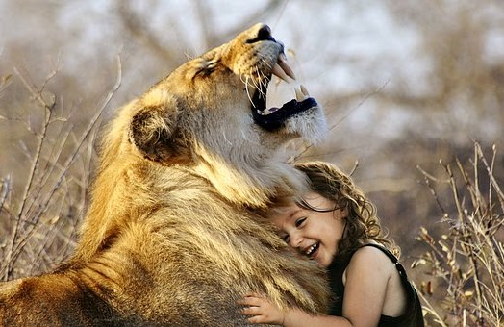

**Notizen:**

|  |
| --- |
|  |
|  |
|  |
|  |
|  |
|  |

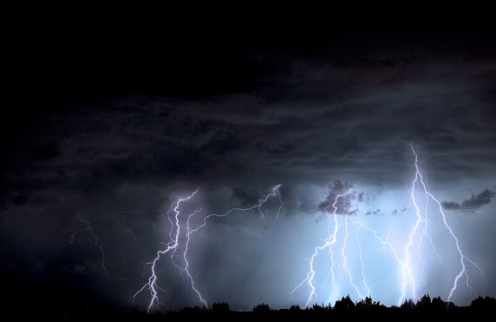

**Notizen:**

|  |
| --- |
|  |
|  |
|  |
|  |
|  |
|  |

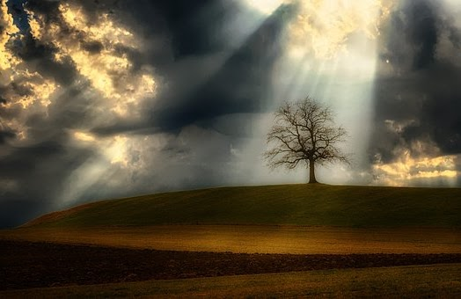

**Notizen:**

|  |
| --- |
|  |
|  |
|  |
|  |
|  |
|  |

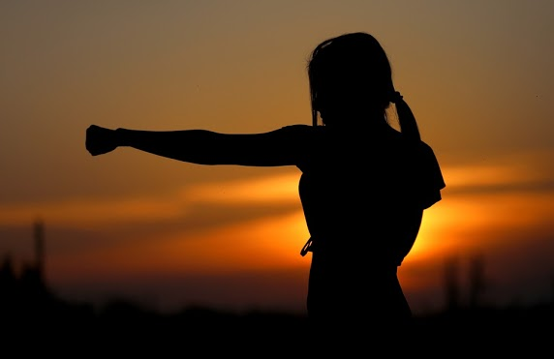

**Notizen:**

|  |
| --- |
|  |
|  |
|  |
|  |
|  |
|  |



**Notizen:**

|  |
| --- |
|  |
|  |
|  |
|  |
|  |
|  |



**Notizen:**

|  |
| --- |
|  |
|  |
|  |
|  |
|  |
|  |

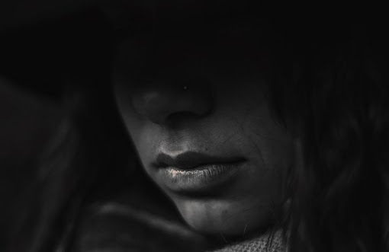

**Notizen:**

|  |
| --- |
|  |
|  |
|  |
|  |
|  |
|  |



**Notizen:**

|  |
| --- |
|  |
|  |
|  |
|  |
|  |
|  |

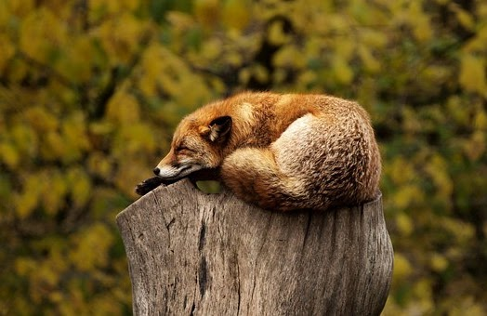

**Notizen:**

|  |
| --- |
|  |
|  |
|  |
|  |
|  |
|  |

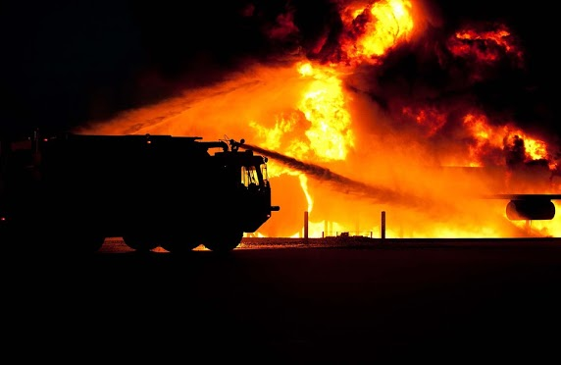

**Notizen:**

|  |
| --- |
|  |
|  |
|  |
|  |
|  |
|  |

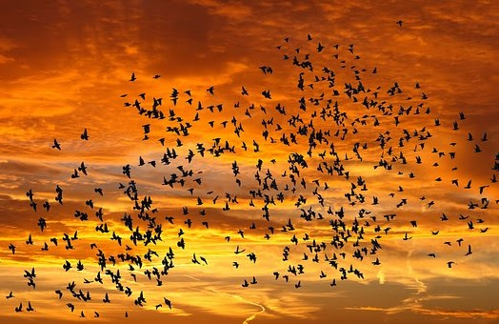

**Notizen:**

|  |
| --- |
|  |
|  |
|  |
|  |
|  |
|  |



**Notizen:**

|  |
| --- |
|  |
|  |
|  |
|  |
|  |
|  |



**Notizen:**

|  |
| --- |
|  |
|  |
|  |
|  |
|  |
|  |

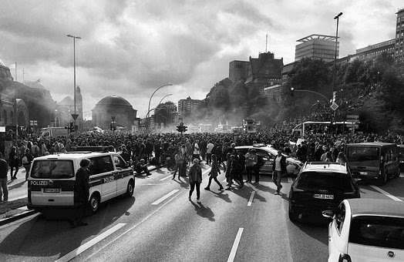

**Notizen:**

|  |
| --- |
|  |
|  |
|  |
|  |
|  |
|  |

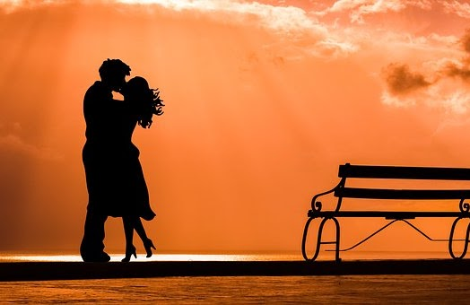

**Notizen:**

|  |
| --- |
|  |
|  |
|  |
|  |
|  |
|  |

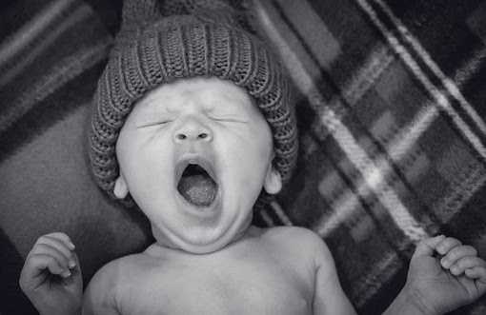

**Notizen:**

|  |
| --- |
|  |
|  |
|  |
|  |
|  |
|  |



**Notizen:**

|  |
| --- |
|  |
|  |
|  |
|  |
|  |
|  |

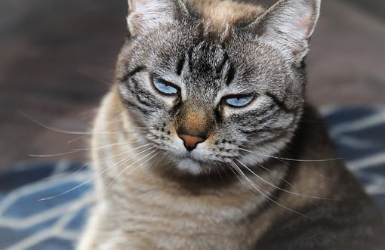

**Notizen:**

|  |
| --- |
|  |
|  |
|  |
|  |
|  |
|  |

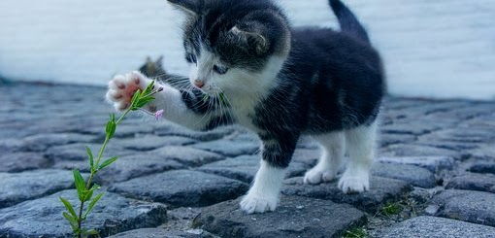

**Notizen:**

|  |
| --- |
|  |
|  |
|  |
|  |
|  |
|  |

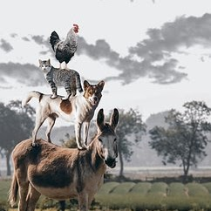

**Notizen:**

|  |
| --- |
|  |
|  |
|  |
|  |
|  |
|  |

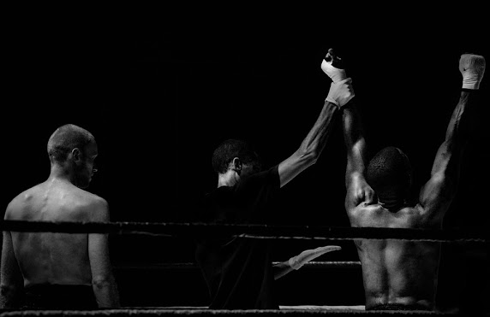

**Notizen:**

|  |
| --- |
|  |
|  |
|  |
|  |
|  |
|  |

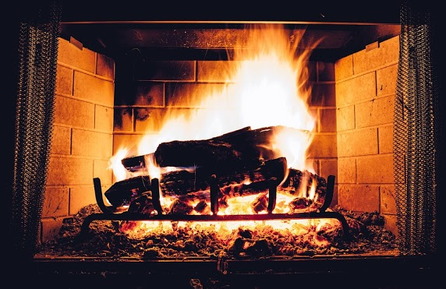

**Notizen:**

|  |
| --- |
|  |
|  |
|  |
|  |
|  |
|  |

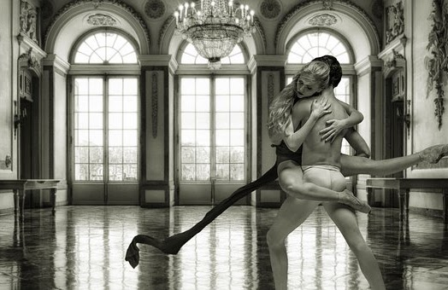

**Notizen:**

|  |
| --- |
|  |
|  |
|  |
|  |
|  |
|  |

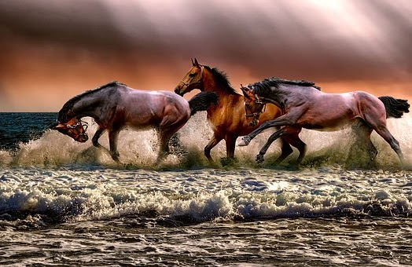

**Notizen:**

|  |
| --- |
|  |
|  |
|  |
|  |
|  |
|  |

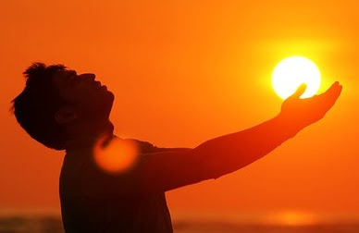

**Notizen:**

|  |
| --- |
|  |
|  |
|  |
|  |
|  |
|  |



**Notizen:**

|  |
| --- |
|  |
|  |
|  |
|  |
|  |
|  |